**DAYSTAR SECONDARY SCHOOL-WAKISO**

**END OF YEAR EXAMINATION 2022**

**CHEMISTRY**

**SENIOR ONE**

**SECTION A**

1. The figure below shows a set of apparatus in the laboratory. Use them to answer questions that follow

F

E

C

B

A

D

G

a) Name the apparatus (5marks)

A…………………………………….

B……………………………………..

C………………………………………

D………………………………………..

E………………………………………..

F………………………………………..

State the functions of the apparatus from experience in the picture above (3marks)

A…………………………………………………………………………………………………………..

G…………………………………………………………………………………………………………..

F……………………………………………………………………………………………………………

c) Outline four ways how you can conduct yourself in the laboratory during a chemistry experiment to ensure that everyone in the laboratory is safe (4marks)

……………………………………………………………………………………………………………………………………………………………………………………………………………………………….……………………………………………………………………………………………………………………………………………………………………………………………………………………………….

2. A large crystal of potassium permanganate was placed in the bottom of a beaker of cold water, and left for several hours

Beaker

Cold water

Potassium permanganate crystal

a) Describe what would be seen

1. After five minutes (2marks)

……………………………………………………………………………………………………………………………………………………………………………………………………………………………….

1. After several hours (2marks)

……………………………………………………………………………………………………………………………………………………………………………………………………………………………….

b) Explain your answers using the idea of particles (3marks)

……………………………………………………………………………………………………………………………………………………………………………………………………………………………….……………………………………………………………………………………………………………………………………………………………………………………………………………………………….

3. You must have learnt the fact that even though chemistry is a laboratory science, it doesn’t stop in the laboratory. In our everyday life, we use very many materials, with different properties. The pictures below show different materials that we use at home.

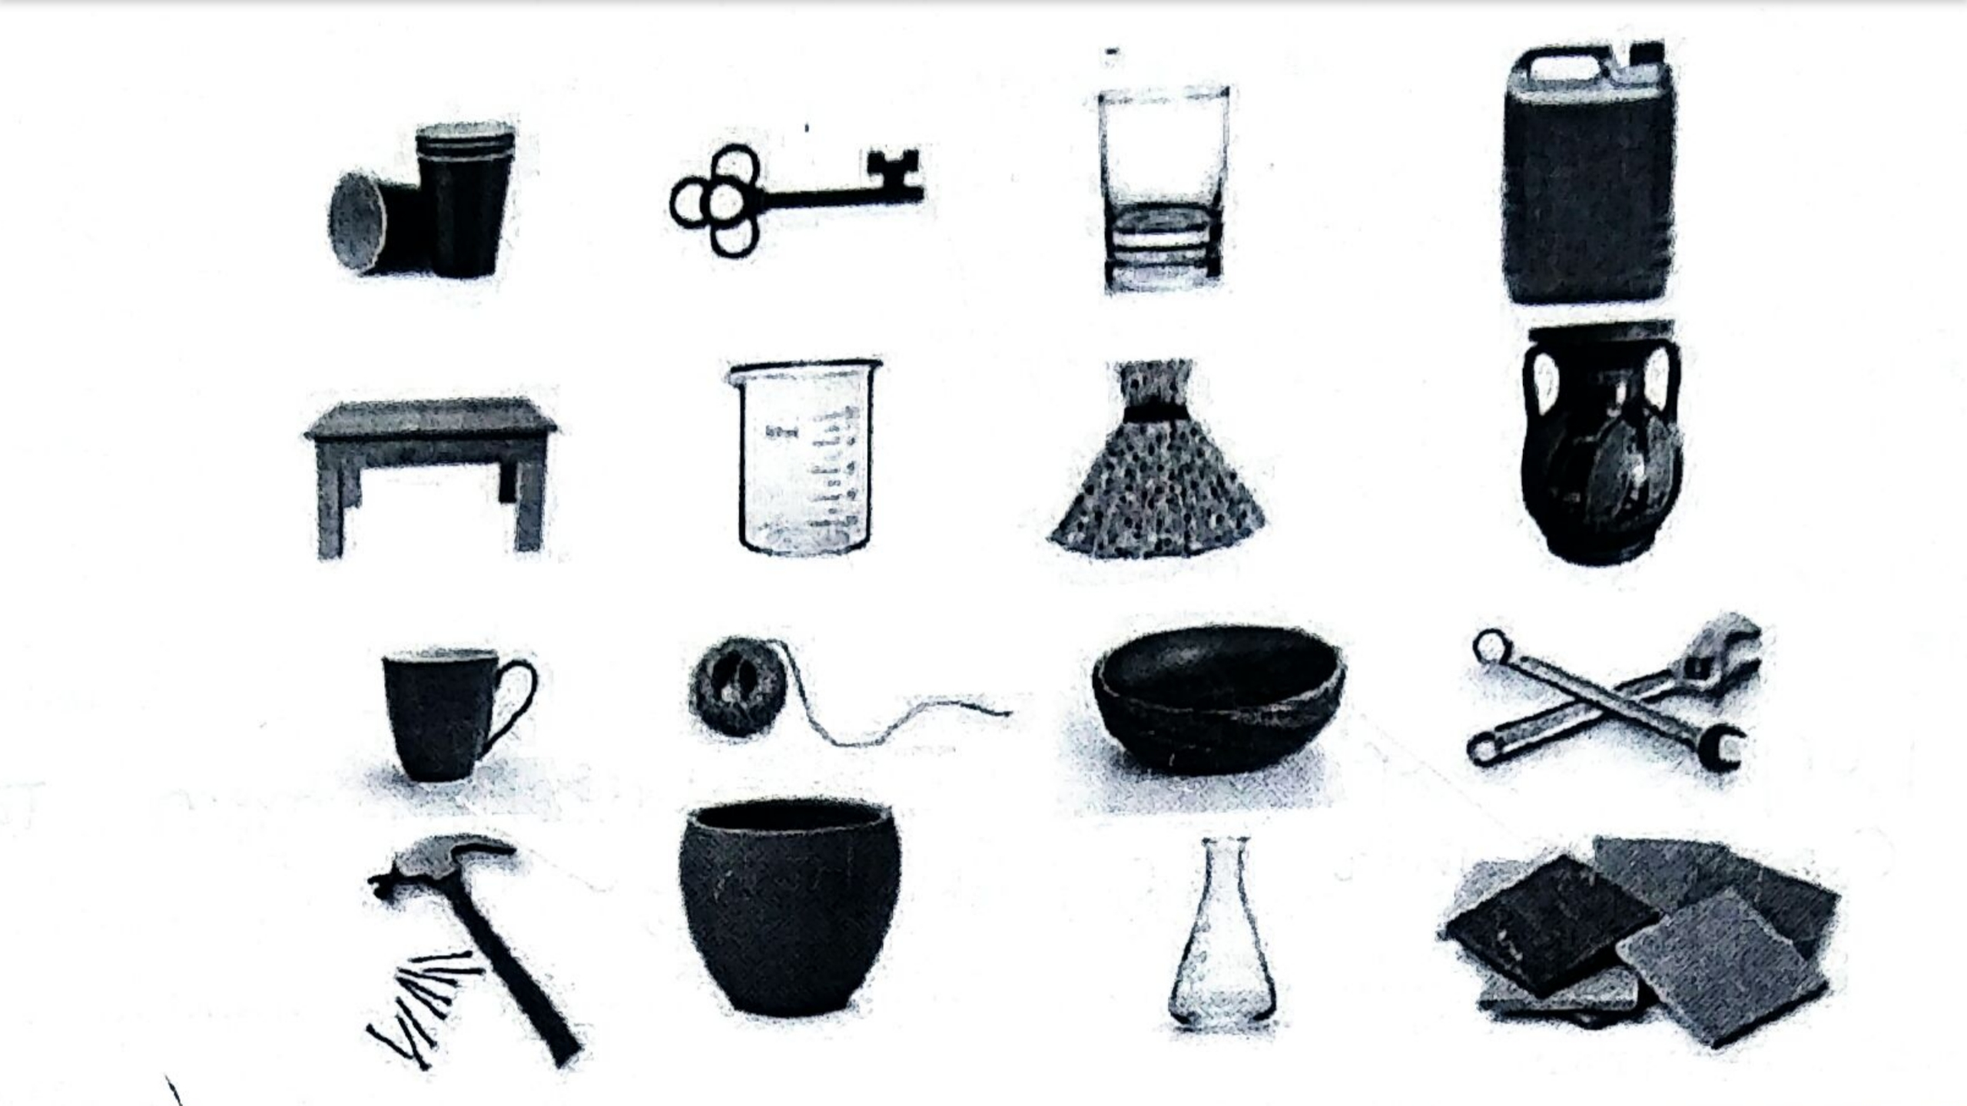

a) Using your knowledge about using materials, Suggest the type of materials and from the list, write down examples of things made from that particular material. (6marks)

|  |  |
| --- | --- |
| Material | Name of item from the picture |
|  |  |
|  |  |
|  |  |
|  |  |
|  |  |

b) The use of plastics in our daily life has greatly had a negative impact on our natural environment in the past years.

1. Outline any two harmful effects of plastics in our environment (2marks)

……………………………………………………………………………………………………………………………………………………………………………………………………………………………….

1. Outline three ways in which we can reduce the harmful effects of plastics in our environments (3marks)

……………………………………………………………………………………………………………………………………………………………………………………………………………………………….……………………………………………………………………………………………………………………………………………………………………………………………………………………………….

4. Matter is anything that occupies space and has weigh. Matter exists in different states. A state of matter is one of the distinct physical forms in which matter exists.

a) Below are diagrams showing different states of matter. Use them and answer the questions that follow.

R

Q

P

1. Name the state of matter

P………………………………………………………………………………………… (1mark)

Q………………………………………………………………………………………… (1mark)

R………………………………………………………………………………………… (1mark)

1. Complete the table below for the properties of state P, Q and R (5marks)

|  |  |  |
| --- | --- | --- |
| State of matter | How particles are arranged | Attracted forces of attraction between particles |
| P |  |  |
| Q |  |  |
| R |  |  |

1. State the properties of each state of matter as a result of arrangement of particles and the attractive forces between them

P………………………………………………………………………………………… ………………………………………………………………………………………… ………………………………………………………………………………………… (2marks)

Q………………………………………………………………………………………… ………………………………………………………………………………………… ………………………………………………………………………………………… (2marks)

R………………………………………………………………………………………… ………………………………………………………………………………………… ………………………………………………………………………………………… (2marks)

b) In the table below, name the process for the change of state of matter and in each case; state weather heat energy is absorbed or heat energy is released during the change of state. (3marks)

|  |  |  |
| --- | --- | --- |
| Change of state | Name for process | State weather heat energy is absorbed or released during the change of state |
| R to P |  |  |
| Q to R |  |  |
| P to R |  |  |

5(a) State two differences between permanent change and temporary change/ physical change (2marks)

……………………………………………………………………………………………………………………………………………………………………………………………………………………………….

b) Study the following chemical equations (2marks)

Heat

Zinc oxide zinc oxide

White yellow

Heat

Potassium manganate (VII) Potassium manganate (VI) +manganese oxide + oxygen

Heat

Hydrated copper (II) v copper (II) oxide +water –oxide

Identify the changes (3marks)

……………………………………………………………………………………………………………………………………………………………………………………………………………………………….……………………………………………………………………………………………………………………………………………………………………………………………………………………………….

**SECTION B**

**(Attempt Any Two Questions)**

11. a) Use the particles theory of matter and explain the following observations

1. An inflated balloon expands and eventually bursts on leaving it exposed to sunshine
2. An inflated balloon eventually sinks when left on a cemented flow for 3 days
3. You can easily squeeze a plastic gas syringe that is completely filled with air, than squeezing the one which is filled with water
4. When tea bag is put in a cup of hot water, colorless water changes to dark brown

b) Explain why the rain water is always slightly acidic

12. a) Name five sources of natural water. (5marks)

b) Describe the process of purification of the tap water that we normally receive in our communities (10marks)

c) Explain how natural water is recycled (5marks)

13. Look at the chemicals listed below and answer the questions about them. You can use the table below showing the periodic table to help you.

|  |  |
| --- | --- |
| Iron | Water |
| Sand | Oxygen |
| Gold | Carbon dioxide |
| Helium | Carbon |
| Rust | Sea water |

1. Name the two metals (2marks)
2. Name two compounds (2marks)
3. Name a mixture (1marks)
4. Name a non-metallic element that is a solid (1mark)
5. You have a solution of sugar in water. You want to obtain the sugar from it
6. Explain why filtering will not work (4marks)
7. Which method will you use instead (1mark)

g How would you separate salt and sugar?

h) Mention any special safety precautions you would take (4marks)

Differentiate between mixtures and compounds (5marks)

14. a) What is a rock? (1mark)

b) i) Name three types of rocks (3marks)

ii) Describe the formation of the named rocks above (16maks)

**END**